Standards and Quality Report 2021 - 2022

Name of school
Rosneath Primary School & ELCC

Context of the school
Including some or all of the following:
- basic school details (roll, class composition etc.)
- school vision, value and aims;
- local contextual issues;
- factors affecting progress (e.g. staffing changes/issues).

At Rosneath Primary School and ELCC we have a total school roll of 99 children, educated across 4 composite classes, with four full time teachers, and one part-time teacher and one specialist music teacher. We have a total of 4 part-time Additional Support Needs assistants, including classroom assistant hours. Our staffing is supplemented by Pupil Equity Funding and Scottish Attainment Funding, targeted across the Primary School and ELCC.

Rosneath ELCC opened at the end of August 2020. Our Pre-School setting can provide education up to 24 children full time and we currently have 21 children registered. This is staffed by three full-time practitioners and one part-time Early Years Classroom Assistant; providing support during snack and lunches.

Intervention 2 Internal successful ASN assistant candidate was appointed as Family Liaison Officer, which required us to fill the ASN assistant hours within school. This took a number of weeks to fulfil due to the high demand of supply staff and lack of availability within the locality. Once recruitment was secure the Family Liaison Officer allocated hours were consolidated from Nov 21 until the end of March 21.
All funding has now been spent and no further changes have been requested.

Intervention 3 Requirement of training for all staff was planned and delivered in partnership with Northern Alliance. This was coordinated by the SAC teacher and delivered in September. Intervention 3 began in October after the holiday for all targeted children. Absence has varied due to the same reasons detailed above.
All allocations have been spent and no further changes were requested.

Rosneath Primary School

School Vision, Values and Aims

‘Learning with a happy heart and healthy relationships’

Nurturing pupils and providing a kind, caring and safe, secure and happy learning environment is at the heart of our school.

Our Values
Resilient Rosneath
Respects Rights and Responsibilities
Resilient
To be able to deal with the ups and downs of life.
Rights
That we give ourselves and others the best chance to learn.
Respectful
We respect everyone and we try to be as kind and thoughtful as possible. We look after other people and our school.
Responsible
In a responsible school we look after everyone and we follow our rules because they help to keep us

Our Aims
- Our school and wider community aim to provide an inspiring environment with high quality learning for our children and young people.
- We aim to support our children and young people to be the best they can be, both in the classroom and the community.
- Through close working relationships between school, our pupils, their families and partners, we aim to ensure the best possible start in education and life-long learning for our children and young people.

We believe the best learning happens when:
- Children lead their own learning
- Opportunities are given to work independently and collaboratively
- Children are engaged and purposeful
- Learning is experienced and active
- Learning takes place in the natural environment and outdoors whenever possible
- Learning provides challenge and is differentiated
- Learning is well planned and organised
- We nurture the whole child
We use Unicef’s UK Children’s Rights to promote an ethos and culture where children’s rights are learned, taught, practices, respected, protected and promoted.

Curriculum Rationale
Rationale Poster
‘Learning with a happy heart and healthy relationships’

Nurturing pupils and providing a kind, caring and safe, secure and happy learning environment is at the heart of our school.

Our Key Drivers
Learning for sustainability, Excellence and Equity
- Rights and values based education
- Local community identity and global citizenship
- Improving attainment and achievement of all
- Health and Wellbeing
- Critical thinking and collaborative action research
- Biodiversity and tackling climate change
- Social justice and Fair Trade
- Outdoor learning and contact with nature
- Peace and conflict
- Developing and learning skills for life and work

We promote a Growth Mindset - Rosneath PS
(P5-7 * an idea from the ideas from P7/6 linking into Restorative Practice, Whole School Nurture)

RIGHT TO BE YOU, BE BRILLIANT
OVER COME OBSTACLES
SUCCESSFULLY FACING NEW CHALLENGES
NURTURING YOUR NEEDS
EFFORT TO GO FOR IT
ASPIRATIONAL GOALS
TEAM WORK
HAPPINESS

PERCEVERE-DON’T GIVE UP
STRIVE TO IMPROVE
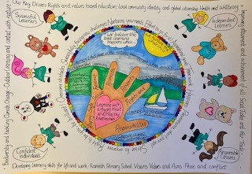

Establishment Context

Rosneath Primary School and ELCC is a non-denominational and co-educational school situated in the heart of the village of Rosneath. Built in 1967, it has the stages Primary 1 to Primary 7, in four composite classes and is housed in one main building. A large school hall provides space for physical education and drama. Music has been taught to classes and in bubbles this session and online via Glow Meet and Google classroom. The general purpose room has been up scaled to become a classroom and one additional classroom has acted as a staffroom due to COVID-19 guidance, however is being converted to a nurture room. Our whole school book banded library (SAC) is situated in our long classroom corridor and each class has their own class library. Following the success of ACHA housing funding (2019), an additional kitchen facility has also been fitted within the additional classroom to support the delivery of Food and Health education, and weekly STEAM lessons are delivered to pupils, utilising the kitchen to cook and prepare some of our new catering menu with pupils.
Hermitage Academy is Rosneath Primary’s associated secondary.

The school is staffed by 5 teachers including the Head Teacher and one Principal Teacher. Our Music Specialist teacher and Additional Needs Pupil Support Teacher visit pupil’s school once a week.
Families play a critical role in the education of their children and at Rosneath Primary and ELCC and there is a long standing, but ever-developing sense of partnership. The co-operation which children shown in our school is a reflection of the positive attitude of our families and is crucial to the success of the community education process. There are opportunities throughout the year for forging home-school links. Family engagement is a focus we strive to encourage and improve upon to offer support to our most vulnerable families. We deliver a free daily breakfast bar and healthy snack at morning interval for all children in partnership with the Co-Op and PTA. We are also part of the Co-Op Food share scheme since 2020. Our tailored school Partnership Program has successfully engaged over 25 families over the course of four academic sessions continually supported through funding from the Scottish Attainment Challenge, with our Family Liaison Officer available this session.

Rosneath Primary enjoys close links with St Modan’s Church and St Gilda’s Parish. Our local Minister has returned to delivering monthly assemblies in school since COVID-19 restrictions have eased.
Our school community has grown and developed with the neighboring area and many members of the village make a very welcomed contribution to the life of the school.

We previously had 5 regular local volunteers who visited the school on a weekly basis to support paired reading and help to deliver extra-curricular activities, such as; Storytelling, Fly Fishing. School activities such as Church Services, concerts, sports days and fundraising events are all supported by our families and community. We normally run between 14 - 17 clubs every session, through staff and volunteer support. This session we were unable to run clubs, but were able to deliver scripted plays from each class at Christmas, interactive whole school workshops and daily communication of pupil learning through Seesaw.

The Scottish Attainment Challenge

In October 2015 we were identified as one of the 57 schools across Scotland to take part in the Scottish Attainment Challenge based on our locality deprivation index.
The Scottish Index of Multiple Deprivation (SIMD) is the official tool for identifying and comparing deprivation levels across Scotland. SIMD identifies small area concentrations of multiple deprivation across all of Scotland in a consistent way. It allows effective targeting of policies and funding where the aim is to tackle deprivation.

Our initial aim was to raise the attainment of our children in reading across Primary 4/5/6 and in doing so, close the equality gap. We introduced a range of strategies to improve the teaching of reading and the impact exceeded our expectations. All strategies are now embedded across the school from P1-P7, and continue into our current session. We have seen an increase in literacy attainment across all aspects, evidenced in our school tracking tool.
Following this, we shifted our Attainment Challenge Focus to primarily be on numeracy and maths, and improving standards of consistency within learning and teaching across the school. This has been an aspect of development over the previous session and into our second year.
This session we were awarded around £23, 867 (21/22) utilized to deliver three intervention priorities. (Please see 21/22 SAC Proposal attached)

Due to high staffing absence across the locality in schools (Aug 21-Mar 22), staffing registered as supply were utilised immediately and left zero availability for cover. This either reduced the delivery of interventions or paused interventions this session.
Pupil absence has been higher due to children either displaying symptoms or requiring a PCR test, family isolation, travel isolation or positive covid results. This has reduced the amount of time a child could have received an intervention and increased the possibility of gaps and the additional time to ‘catch up’ to reinforce learning.
Families are not always in a position to fulfil home learning or teaching interventions when a child is absent due to covid related illness. (Aug 21 – Mar 22)
The school have given families the opportunity to engage with intervention information through; seesaw virtual classroom, their child’s seesaw account, power points, sway newsletters, and online workshops, however the level of engagement has still been much lower than we perceive it would have been if they had been able to visit their child’s classroom and ELCC and talk with staff.
Appointments with the Family Liaison Officer have been cancelled unexpectedly due to covid related illness between Nov 21 – Mar 22.

Intervention 2 Internal successful ASN assistant candidate was appointed as Family Liaison Officer, which required us to fill the ASN assistant hours within school. This took a number of weeks to fulfil due to the high demand of supply staff and lack of availability within the locality. Once recruitment was secure the Family Liaison Officer allocated hours were consolidated from Nov 21 until the end of March 21.

COVID – 19
Pupil Equity Fund

In May 2017 we had notification of a significant allocation of £32,000 from the Scottish Pupil Equity Fund, which is distributed on the basis of the number of pupils in receipt of free school meals.
Session 2017/18 have worked in partnership with Education Scotland, University of Glasgow, The Robert Owen Centre for Education. Our Collaborative Action Research enquiry exceeded our expectations from staff and pupils. This created a new collaborative learning community at all leader levels. Session 2019/20 we continued to develop in collaborative practitioner enquiry and coherent approaches to build and sustain practice with a focus on Numeracy, and in particular Problem Solving Skills.

In addition to Collaborative Action Research we previously established a service agreement with Children’s First, third sector to support a small number of targeted child and families, both through home and school visits in raising attendance. This was successful in its initial phase, however Children’s First became disbanded within the Helensburgh & Lomond.

Session 20-21, Pupil Equity Funding promoted pupil engagement and health and wellbeing, returning from school lockdown during COVID-19, during term 1 from August 2020 to October 2020. We increased class teacher FTE across the school and reduced composite class sizes to straight classes from Primary 3 to Primary 7. This allowed a reduced learner ratio and therefore ensured more focused quality learning and teaching, increasing pupil engagement. Following 3 PTA online meetings in June 2020, family feedback welcomed the proposal of reduced class sizes funded through our school PEF 20/21 allocation to support the return to school. Families also associated smaller class sizes with the potential reduction in COVID-19 risk amongst classes, supporting parental voice. A daily mix of outdoor learning, outdoor P.E lessons and Health and Wellbeing lessons were provided on the basis for teacher holistic assessment to capture pupil engagement. This was also supported with the completion of the pupil survey; ‘Myself as a learner’, class teacher HIGOS 4 self-evaluation tasks, support staff questionnaire and family questionnaires using monkey survey.

Over 40% of school community roll requiring support as evidenced on SEEMIS, with 30% of roll experiencing family issues and 15% registered as young carers and 8% Care Experienced families, Jun 22.

Review of SIP | Priority 1
Progress and Impact:
Literacy – Wraparound Phonics S.A.C - Priority 3
- All x14 targeted children from P4-7 improved by +6mths by March 22, with almost all children increasing in enjoyment and confidence for spelling, this has been evidenced through pupil discussions and class teacher observations.
- Pupil comments:
“I’m really enjoying spelling and working with my friends.” P4
“I’m getting better at spelling.” P6
“It’s fun being able to grow your own words and challenge each other.” P6

- All x14 targeted children are able to confidently process the building of a root word, adding prefixes and suffixes.
- All x14 children know their spelling rule and weekly grapheme, helping them to increase spelling accuracy in all weekly writing contexts, evidence through jotter work samples, weekly writing lessons and weekly assessments.
- All children receive for 4 root words each week and children differentiate their own learning and decide how far they want to challenge themselves in the number of words or by the length of word. Pupils are using their prior knowledge to reinforce learning from abstract to concrete, using visual resources to support independent learning and reinforce academic resilience.
- The school moderation process offered opportunity for peer staff observations, which allowed staff to further develop active learning and teaching approaches; this improved quality of consistency of learning and teaching and increased staff confidence.
- Moderation observations allowed reflective discussions to share lesson planning, which increased consistency in learning and teaching experiences. This also supported staff delivery, increasing confidence and enjoyment in delivery of learning and teaching of spelling.
- Qualitative and quantitate data showed an increase in pupil engagement through enjoyment for spelling and an improvement in attainment.
- Out of 56 children (2 absent on the day of assessment) 47 have increased in spelling age. This equivalents to 84%
- 52% of children improved their spelling age by 6 months (29 out of 56 children)
- All targeted children increased their spelling age between September 21 and June 22.
- The lowest improvement in spelling age was +6 months between September 2021 and June 2022.
- The highest improved spelling age in one child was +2.6 years from September 2021 - June 2022.
- All targeted children were assessed 4 times throughout the academic year; September 2021, December 2021, February 2022 and May 2022.
- Increased confidence in children’s own abilities, offering control over their own learning.
- Highland literacy programme provided resources to facilitate learning and teaching lessons, which supported all children in developing their knowledge and understanding of the WRAPs process.
- Resources were purchased to the value of £300, shared between classes and this consolidated the weekly spelling rule and offered extension and challenge for more able pupils.
- We were provided with virtual training at the beginning of the academic year by Jenny Wilson, one of the lead practitioners of Wraparound Spelling and Highland Literacy from Northern Alliance. The training was recorded and emailed to all members of staff. Additional training videos have been shared with staff, as well as stored in the WraSp Glow tile for easy access. Staff confidence increased consistency in Learning and Teaching across classes and accessible resources support ongoing CPD.
- SAC teacher created a SWAY presentation informing families about the Wraparound Spelling scheme which has been introduced throughout the school. The presentation explained the spelling scheme in detail and included tutorial videos for visual representation.
- Relevant websites were also linked throughout for further information. The presentation was sent to all families via the Xpressions App. This informed families of new spelling pedagogy and further information around the spelling rules.
- SAC teacher also created a WraSp virtual classroom; this was linked in the SWAY presentation and is easily accessible for families and pupils at any time.
- Assessment data is stored both on the shared drive and on the GLOW WraSp tile. All data is easily accessible and transparent for all teachers, this allows for shared planning and dada analysis during curriculum planning meetings.
- Repetitive language of talk4writing increased pupil confidence and range of vocabulary, supported by improvements in spelling evidenced in non-fiction writing pieces.
- ELC and P1/2 development of outdoor literacy writing areas encouraged independent writing through play for most children.

Next Steps:
- All pupils from P2 to P7 will be taught using wraps from August 22 to June 23.
- All children from P2 to P7 will increase in ability, understand the process of building root words, adding prefixes/ suffixes
- All x14 targeted children will attain according to their development age by June 23.
- All children from P2 TO P7 will be able to transfer their spelling process and apply in all written contexts.
- Increase awareness to whole community campus from ELCC to P7 by access to virtual classroom, wall display, increase phonological concrete resources across early years and outdoors.
- Moderation to include all staff from ELCC to P7 to evaluate quality and planning of Learning & Teaching for WRAPS, from August 22 to May 23.

- Collaboration with neighbouring schools to moderate key writing assessment to support learning and teaching.
- Implantation of literacy learning logs throughout whole school community to capture pupil engagement and raise attainment.
- Introduction of share talk4writing focus across all early years, shared planning and reviewing progression across all terms.
- Further Talk4Writing for whole school community by Dec 22.
- Creation of a shred literacy library to support stories through different subjects/ themes, by sharing whole community resources.
- Continuation of whole school community outdoor writing stations/ opportunities.
- All early years children to create produce QR video talks and regularly share stories both in campus and online with families, every week.

Review of SIP | Priority 1
Progress and Impact:
- P1 teacher engaged in regular data tracking sessions with ELCC practitioners, however due to the increase in positive cases with COVID-19 during term 2 and 3, no specific numeracy targeted sessions were delivered to support individual children.
- We have a total of 19 children targeted across P1-7 for SEAL intervention. We anticipate 85% out of the total 19 children, to achieve 10% increase in their fluency and accuracy abilities, assessed through GL Assessment.
- All teaching staff, support staff and ELCC practitioners attended two in-service training sessions, focusing on 4 operations and problem solving, data handling which developed confidence and supported active and motivating learning and teaching strategies. This also facilitated teaching of targeted areas of intervention for all targeted children.
- Original targeted number of children was 21, this reduced to 18 children, since three moved out of the area.
- From August 21 to Feb 22 13 out of 15 targeted children improved in their Scale Score within their Star Maths assessments. One child regressed in their star assessment and one remained. 3 children do not sit the maths star assessments in P2.
- 12 targeted children out of 15 children improved in their standard NRSS scores from August 21 to Feb 22.
- 12 targeted children are now recorded within the green area, assessed as on track within their star maths assessment.
- SAC teacher utilised SEAL strategy teaching guides and the SEAL A2 SEAL planner.
- SAC teacher has created termly plans for all 21 targeted children inline with previous assessments data.
- All targeted families received a PowerPoint presentation on SEAL, posted via seesaw and all families are able to access a SEAL virtual classroom with links to support materials and you tube video links.
- All families received an invitation link to ZOOM ‘Count On Us’ 30 minute sessions to support teaching maths at home.
- A wide range of resources have been used to engage the children who have been identified as needing extra support in accessing the Maths and Numeracy curriculum.
- Extra resources were purchased following discussions with class teachers to provide further resources for use both in the small group sessions and in whole class lessons.
- SAC teacher sent out a family survey, two families commented on the Count on Us zoom session, SEAL PowerPoint and virtual classroom;
“It was great to be able to have the strategies currently taught explained so that I can support learning at home more effectively.”
“It was good to see what methods were being used at school to then be able to talk about them and use them at home.”
- The boost to students confidence has contributed towards the improvement in their understanding of Maths concepts. Most children have shown more motivation to work in smaller groups.
- Assessment data is stored both on the shared drive and in GLOW on the SAC Seal tile.
- All data is easily accessible and transparent for all teachers. Data is regularly discussed at staff meetings.
- A small group of pupils choose to shared their views on maths and numeracy using ‘wee HGIOS’;
P1 Pupil - “I like number before and number after, and working with Primary 2s in my class. I prefer my whiteboard to do my work.”
P2 Pupil - “Doubles help you learn.” Pupil wrote down 1+1=2, 4+4=8
P3 Pupil - “I enjoy times tables and addition”
P4 Pupil - “I enjoy Times tables and using songs, video clips to help me learn. I don’t enjoy money, but I can see the advantage of being able to use money when you go to the shop.”
Targeted P6 - “I enjoy ‘chimney sums’.” She doesn’t enjoy Times Tables and would like more practice in school.”
P6 Pupil - “I enjoy division and you really need your times tables for it. I don’t particularly enjoy weight and I prefer practical maths, compared to textbooks, as it helps you understand more.”
P7 Pupil - “I enjoy fractions, though they are not easy. I don’t enjoy shape work, as I’ve never understood it. I would like more work on this.”

Next Steps:
- Shared planning across Early Level to support learning and teaching of numeracy and support of individual identified children with planning tracked through developmental milestones and E&O school devised tracker to evaluate individual children.
- Using PEF teacher intervention to support the ongoing targeted support across ELCC to P7 following May assessment ’22 data, delivered three mornings a week.
- All staff to implemented E& O tracking tool to support learning and teaching, monitoring individual pupil progress from Aug 22.
- PT to attended CGI training and cascade to all staff.
- Further parental/family workshops in school and class homework challenges to increase engagement.
- SEAL teacher to work in partnership with new SEAL teacher.
- Continuation of program until June 22 and further continue from August 22 to current utilising PEF allocation.
- 3 children out of 18 children have improved and will no longer require further SEAL intervention.

Review of SIP | Priority 2
Progress and Impact:
- Due to high staff absence we have been unable to establish a working party this will follow onto next session.
- All staff attended LGBTQ training and implementing curriculum, this increased staff confidence and consistency across learning and teaching:
“I feel much more confident in understanding LGBTQ history and confidence in understanding different acronyms.” Staff member
- Almost all P5-7 children are confident in recognising and understanding the LGBTQ curriculum, reducing pupil anxiety and vulnerability.
“I know my own pronouns. They can be different to other peoples.” P6
“I talk to my nan about everything and I feel much more confident.” P6
- Most children across whole school campus have a greater understanding of different family dynamics and friendships, resulting in further child discussion and awareness with their class teachers, practitioners.
- Offering further opportunities for discussions amongst families at home due to families receiving information prior to teaching.
- 75% of all pupils from P3-7 are confident in sharing 2 articles from UNCRC, children are more confident in their recognising their rights and responsibilities within and out with school demonstrated through pupil discussions, circle time and peer activities.
- Due to Covid 19 we were unable to create a virtual/ school family trauma event.
- All staff completed trauma informed practice modules, linking to authority Educational Psychology service, increase staff knowledge and confidence.
- Most staff agareed they feel stronger in their knowledge and understanding of ACES.
- 5 Targeted families referred to Family Support Worker from ELC to P4.
- 13 Targeted families referred and working with Family Liaison Officer from P4-7.
- All families have named contact support family engagement strategy, with all referred children having a named contact/ trusted/ safe space to talk.
- All families have received increased support through referral to relevant outside agencies working in partnership with SMT, FLO AND FSW.
- All targeted children and families have increased confidence and reduced anxieties:
“Janet has been amazing to work with.” Parent/Carer Comment
“Lynne goes above and beyond to Support us.” Parent/ Carer comment
Almost all targeted families feel supported and had benefited from the role of the FLO and support worker.
- All families comment their children’s needs are being met because it is individualised targeted support improving child attendance and increasing progress and attainment.
- Some children are able to differentiation from ELC to P1 to facilitate the development of self-control, emotional and social awareness and interpersonal problem-solving.
- Most children can now recognise various feelings and emotions and are able to verbalise how that looks and feels and escalation strategies.
- ELC to P7 children received Teddy Bears and all children can explain the teddy bear policy, sing the song and use them to self soothe and self-regulate their emotions.
Next Steps:
- Establish working party for Equality, Diversity and Inclusion for children, families and staff by June 23.
- Purchase learning and teaching resources to facilitate LGBTQ curriculum and RSHP, for staff and pupils by June 23.
- All children from ELC to P7 to have an understanding of differentiated family dynamics and friendships by June 23.
- All P5 to P7 children will have an understanding of LGBTQ curriculum by June 23.
- Community Health and Wellbeing stall event to support LGBTQ and RSHP curriculum for children and family by December 22.
- All children from ELC to P7 will be confident in sharing and verbalising 2 articles from UNC by June 23.
- All families to receive notification of 2 articles a term shared on ‘Week Ahead’ bulletin, class bulletins and monthly SWAY newsletter by October 22.
- Working in partnership with EP team and CAHMS team deliver family trauma event using hybrid model of online and in school workshops by Dec 22.
- A care experience support group for families of current and former pupils of the community led by FLO and working in partnership with partner agencies such as Health Visiting, EP services, and social work.
- Staff to complete 2nd module trauma informed training for all staff and support staff by June 23.
- All staff to create a child centred curriculum design to respond to pupil’s needs and mindfulness, by Dec 22 utilising Nov in-service.
- All staff to access PATHs training on August 22 in-service.
- All staff to post PATHs lessons on seesaw prior to delivering for families from Aug 22 to June 23.
- All staff delivering and implanting of learning and teaching of PATHs lessons from ELC to P7, delivering a minimum of 2 lessons a week from Aug 22 to June 23.
- Developing outdoor calm teddy bear areas, providing a safe and friendly space for all children, using the outdoor classroom, teddy bear benches within school campus and community working in partnership with pupil council, PTA and community committee by June 23.
- Create Teddy Bear monitors to offer comfort and support, to promote play within whole school campus and community, working in partnership with pupil council, PTA and community Council by Dec 22.

Review of SIP | Priority 2
Progress and Impact:
We were delayed in starting work stream 2, beginning fully at the end of October ‘21. This also delayed some of the training for the Family Liaison Officer and delivery of support. However, this has quickly moved forward due to the post being almost full time.

All family sessions are saved and uploaded to Google Classroom - Family Liaison Tile with regular meetings with HT. This has facilitated communication with senior management and class teachers. It has also supported remote working for staff, if colleagues have to work from home.

The Family Liaison Officer has undergone CPD training; this has increased her knowledge of services available in the locality and nationally, understanding of referral processes and criteria for families to benefit from access to services and strengthening the role of the FLO in collaboration with other services. Some CPD courses have also increased capacity to deliver one to one support around mental health.
The training is detailed below:
- X2 Sessions to support family members in prison linking to (familiesoutside.org.uk)
- Families in Poverty training through Argyll and Bute council -supporting benefits and welfare,
- X2 sessions mental health awareness
- Children’s mental health course.
- Befriender

New links have been made with services such as e’sgoil, Argyll & Bute Befriending Service, Families Outside and a stronger and an increased weekly service has been set up for Young Carers within the school.
Families are happier to have a direct contact at school for support with many aspects of family life such as; benefits applications, support through transitions, bereavement, accessing their child's progress on digital platforms and accessing other services not available locally.
Our new wellbeing tool has given us feedback on how our students feel about their learning and inclusion, which we will use as an ongoing assessment. This wasn’t an easy tool to implement initial, however now we have established the tool, it is simple for children to access and for them to record their views. The range from 1 to 10 in recording responses is still very broad and will have to be adapted for younger pupils.
Families have responded well to the weekly contact by phone and in many cases an in person approach seems to be the preferred choice.
- Out of x5 targeted families, two of the targeted children have now moved away to another locality (Nov 21). This leaves x4 targeted families and x6 children.
- A further x7 families have requested support. This totals x11 families and x16 children, equating to supporting 21% of the school roll.
- X6 Families receive weekly support through; telephone calls, in school visits or home visits.
- X4 Families receive fortnightly support through phone calls, in school visits and home visits.
- X1 Family parent hasn’t engaged, however other family members have engaged through online learning platforms.
- Out of x6 targeted children, one child is engaging remotely and x5 average attendance of 95%
- Out of a total number of x16 children, one child is engaging remotely and x15 average 94% attendance.
- X4 Families have received support for financial advice and application form filling.
- X5 Families receiving support for food bank referrals and school uniform applications.
- x2 Families are seeking support with employment such as; community learning
- X3 Families receiving support for housing applications and communications with housing associations.
- X1 Family seeking support from Charity Outside.
- X4 Families receiving support for Mental Health matters, one family has since moved.
- X3 children referred for Befriender service.
- X7 out of the targeted children have been referred to Young Carers. A total of x14 children are now registered as young carers across the school roll.
- x5 out of 6 targeted children completed surveys from Wellbeing motivation tool;
  - 80% feel they work hard in school.
  - On average out of 10, x5 targeted children gave a score of 8.5 out of 10 for adults who look out for them/ make sure they are feeling ok.
  - 98% felt teachers tell them what they are good at.
  - 88% felt they were listen to in school
- X1 family out of the x5 targeted families engages with seesaw on a weekly basis.
- ‘The school is helping our children come on leaps and bounds. Always approachable and great with the children, our two look forward to their time learning with staff and always have fantastic things to say. It’s also nice knowing they are receiving additional support to help them with their education.’
- ‘Someone to talk to and gain confidence.’
- ‘The school provides a great support to families in need of a bit of extra help. The availability of these services to be widened so more could benefit would be great. ‘
- Family feedback from the targeted families has also indicated:
  - Support services within the rural community are limited such as applications for; Grants for Uniform or Bus Pass, Personal Independence Payment, IT skills support.
  - Community has low level communication and IT support.
  - One family discussed only having their phone as internet access to contact job centre, universal credit which are online calls. There is no free internet access from local shops. Internet connection is low level across the community.

Next Steps:
We are still working towards building more links with community services, simply finding available services that have spaces to work with new clients after covid and with waiting lists being increased has been challenging.

Local services are limited due to our rural location and many services are not able to travel to provide a mobile service. Our families report time constraints of travel along with the costs of travel, making accessing services in Helensburgh prohibited.

Review of SIP | Priority 3
Progress and Impact:
- 84% of Families engaged in online reporting or phone calls from ELCC to P7 with most families opting for telephone appointments to online Glow Meetings. A further 10% of calls were followed up outwit reporting appointments. Despite families preferring the flexibility of a telephone call appointment, this is a reduction in engagement compared to face to face appointments.
- Less than 20% of families across the school community engaged in the virtual ‘Count on Us’ workshops for Early Years and upper school. Families were emailed information following the live sessions and less engagement compared to previous pre-covid workshop attendance by families.
- SWAY monthly newsletter views have increased from 300 in November 21 increasing to over 400 views for our recent newsletter. All SWAY newsletters have averaged a 2 minute viewing.
- 90% attendance from families of children within our ELCC at our first coffee morning and most families attending ‘Pupil Leading Learning’ events May ‘22.
- May ’22 all pupils accessing 1 to 1 ipad device from P1 to P7 and this has facilitated personal learning through AR, AM Sumdog, seesaw and MyOn.
- All children registered as FSM supported to access online learning platforms at home using personal allocated device and this has facilitated learning and increased pupil engagement.
- All teaching and ELC practitioners accessed NA CLD to attended online CPD session with all colleagues undertaking more CPD due to the accessibility of virtual access.
- All staff can access school community SWAY newsletter, attainment SWAY letter and additional SWAY cpd.
- All teaching staff and ELC practitioners confident to access Esoil for additional remote learning tutorial and one pupil accessing Esoil for online one to one tutorials. All staff confidence and awareness has increased.
- All staff accessing and using Teams for calls and planning meetings.
- All children received regular STEAM lessons from ELC to P7, as this was impacted by covid staff related absence.
- Pupils enjoyed weekly STEAM food technology lessons linking to new school menu and increasing pupil knowledge and understanding of ingredients and compounds within food ingredients.
- Children from P1 to P7 engaged in STEAM week.
- All children from P1 to P7 engaged in DYW themed week with 100% of pupils increasing awareness of learning that linked directly to employment.
Next Steps:
- All staff to attend Teams modules to facilitate presentation and setting up a meeting.
- To host DYW week and increase to regular employer visits.
- All families to be offered face to face appointments with additional workshop activities during the same event, with virtual classrooms supporting further information awareness raising.

1.1 Attainment Data
Attainment of Literacy Curriculum for Excellence levels 2016/17, 2017/18, 2018/19, 2020/21 and 2021/22. (teacher judgement – confirmed levels – 5 year trend).
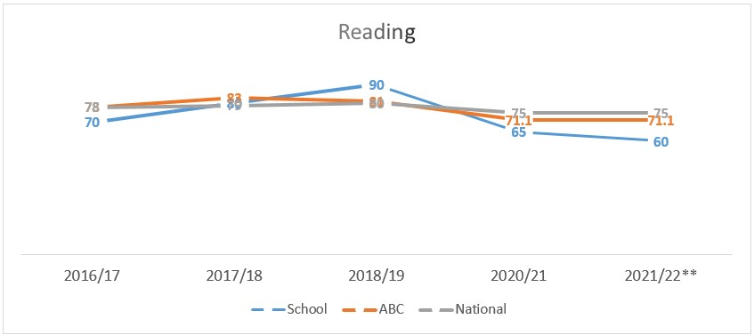
Example – Replace with school-specific data when provided
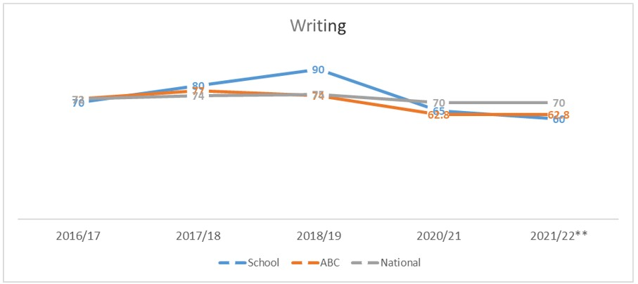
Example – Replace with school-specific data when provided
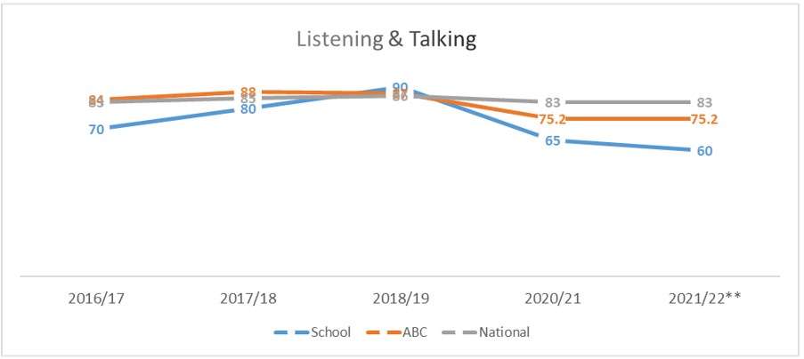
Example – Replace with school-specific data when provided

1.2 Attainment Data
Attainment of Numeracy Curriculum for Excellence levels 2016/17, 2017/18, 2018/19, 2020/21 and 2021/22. (teacher judgement – confirmed levels – 5 year trend).
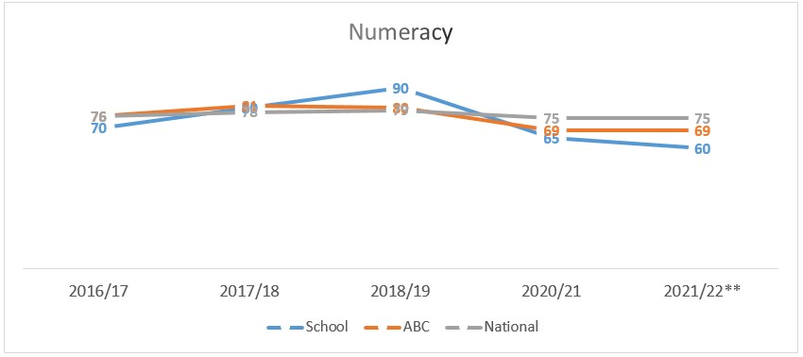
Example – Replace with school-specific data when provided

Please Note:
The above data (1.1 and 1.2) reports achievement of a level – P1/P4/P7 combined.
Due to the Covid 19 pandemic, there was no collection of ACEL data by Scottish Government in 2020.
Overall quality of our learners’ wider achievements Highlights of session 2021 - 2022
Primary 5/6 pupils entered the Keep Scotland Beautiful; ‘2022 One Planet Picnic Pocket Garden Competition’ and we were delighted to be selected as a winner. We are now beginning our adventure to build and grow our garden design.

A Pocket Garden is a miniature garden that uses edible plants, plants that attract wildlife, and that reuses something which would otherwise have been thrown away. The 2022 One Planet Picnic Pocket Garden Competition builds on this, linking garden designs, sustainability and the 2022 Year of Stories.

Each pupil in Primary 5/6 rose to the challenge of planning and creating their own designs; containing edible plants, recycled materials and depicting their favourite story. Pupils then voted on their favourite designs. The winning design was a depiction of ‘The Jungle Book’. Together the children then evaluated their entry design and agreed to make further alterations by including an idea from every child’s design; such as plant, habitat or material.

The class organised a very successful enterprise jumble sale to raise funds for the project and establish a ‘Garden Centre’. Pupils decided to share their enterprise donations by gifting all classes and nursery children a voucher to spend on their garden grounds for wildlife.

The children were motivated to get involved as they all collaborated into the overall design. They worked in groups to identify plants which would be edible to humans and also those which would attract wildlife, sharing knowledge and utilising technology to research. The children have developed an increased awareness of biodiversity and in particular what they can do to boost this within our school community grounds and at home in their own gardens. Pupils had to select materials from a sustainable source - reusing as much as possible and ensuring compost is peat free. The children related this to prior knowledge from learning about climate change studies and the role of carbon.

We are now very excited to begin building and growing our design. Here are some of our pupils comments:
"It's going to be amazing for us and wildlife!"
"When we were finished drawing we voted on the best, then we chose the winning one to build, but we did put in a little bit of everyone."
"I like it because when you look at it there's lots of things to look at."
"I like the design a lot because it looks really cool. I'm looking forward to building it because it will attract wildlife."

P7 Arabic
As part of our Literacy/Modern Languages curriculum, this year’s P7 were delighted to be included in Arabic Live Lessons and Tutorials with our Tutor Rym (who was originally from Tunisia). SCILT offered this fantastic opportunity and I discussed it with the children before applying. They were very keen, as was I, to find out about a Language other than the usual French, Spanish, etc.
In Terms 1 & 2, we took part in Live Lessons with Rym every Thursday (along with 4 other Argyll & Bute Primary Schools) and she also recorded Lessons for us to look at beforehand. Each week we worked on a different Theme (eg Colours, Weather).
Before the Lessons started, we were given a Loan Box containing various Arabic artefacts to familiarise ourselves with Arabic culture. We talked about what we knew already and what we wanted to learn about before opening the Loan Box.
We were then fortunate enough to be given a grant to purchase our own Arabic artefacts, books, games, musical instruments, writing sets, etc. I allowed the children to choose what we were going to purchase.
Children were disappointed when the Lessons were over (10 in total) and the Loan Box had to be returned but excited to know that our very own new Arabic Box would be there for the benefit of all future pupils.
We illustrated a Scottish Folk Story translated into Arabic and read by Rym for the Bethlehem Film Festival (“Shellycoat”) in November, 2021.

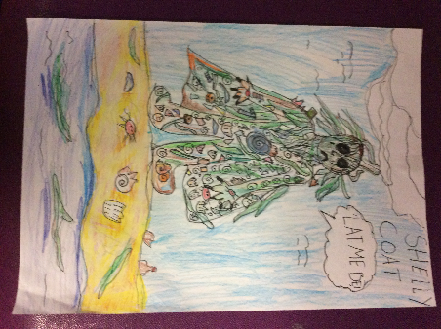

STEAM WEEK

This term the STEAM activities have joined with work focussing on Health and Wellbeing and favourite recipes from our school menu. Planned experiences require Literacy and Numeracy skills as well as co-operative learning groups.
Each class has been in practical work involving using simple recipes, both savoury and sweet, which they have then taken home to share with their families.
We have analysed the ingredients, grouping foods into vitamins, proportion of healthy ingredients and understanding what a healthy diet consists of and why it is good for us. Everyone has also enjoyed learning the importance of hygiene when cooking.

The children had to work together and shared tasks involving measuring ingredients, reading scales, reading and following instructions. They also learnt new skills such as cracking eggs, rolling out dough and tidying up afterwards.

Children In our nursery and up to Primary 4 have had their recipes posted on Seesaw and some have tried them for themselves at home, which has been great!
Children in Primary 5 to 7 are compiling their own recipe books and add to them each week.
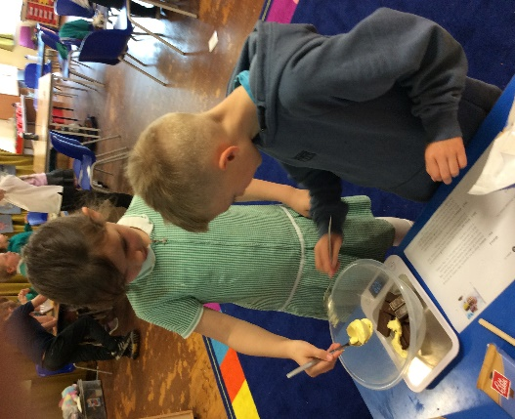

Comment on strategies that have been successful in engaging with children and young people, staff, parents and the wider community and the impact of these.
DYW week
Developing the Young Workforce
Rosneath Primary School and ELCC had a very busy week where members of the local and wider community were invited to come in to school and share their work experiences with the children.
Representatives from the Royal Navy brought engineering building kits for the children to work on and spoke about the kinds of roles there were in the Navy and Mr Craig, the school janitor, gave a presentation, showed photos and talked about his time in the Navy and brought uniforms in for the children to try on.
Mr Hobson from Lockheed Martin spoke about apprenticeships in the company, showed slides of rockets and satellites and spoke about the new satellite launch pad in Shetland. He also brought models of satellites for the children to make.
Mr Hazlett works for Babcocks and talked about the international role that Babcocks have, how they support the defence industry in the United Kingdom and what apprenticeships the company offers. He also brought along his welding equipment to show the pupils.
Mr Travers, who used to be the school janitor, came back to school to talk about his job as a fireman and brought in equipment for the children to try on.
Mrs Gillon, a mum at the school, brought in her hairdressing equipment and talked about her job as a mobile hairdresser.
Mrs Shields is a volunteer with the RNLI and works as their Education officer, she is based at Helensburgh lifeboat station. She worked with all the children and talked about how to be safe near and in the water and what to do if anything goes wrong.
Miss Sadiku, an ex-pupil of Rosneath Primary, came in to tell the pupils about the beginning of her career and the decisions she needed to make.
The children were excited to finally have visitors to the school and asked many questions of the speakers about their jobs. There were many comments from the children who found the speakers really good at sharing information about what their work entailed and made their talks interesting to listen to.
Wee HGIOS / Teddy Bear Policy / Health Week / / Revision of VV, A and sketch note/ Community Garden/ FLO/ FSW

Comment on progress made with the following aspects of empowerment:
- curriculum;
- improvement activities;
- parental and community engagement; and pupil participation.

https://education.gov.scot/improvement/learning-resources/an-empowered-system/?dm_i=LQE,6RTY0,WAUPY4,R37A1,1
Curriculum
- Maths and Numeracy has been a priority for Rosneath Primary and ELCC and as we have securitised our progression pathways our P1/2 teacher took on the role to explore this further to meet the needs of our children and increase depth to daily evaluations with a tool that supported daily tracking not capturing of impact of learning and teaching. Based on Northern Alliance Progression Frame work, L. Gillespie created a tool that track daily pupil engagement, whilst highlighting areas for support. Along-side, children have a personal Numeracy Learning Log in which they collate work as they progress. A personal working document, it holds evidence of learning. Children have chosen the way in which their achievements are evidenced, having full access to their file which allows them to revisit previous learning and to build on their knowledge.
A similar document has been created for all areas of literacy. Children have a working document, personal to their progression through their phonics and reading journey. Children know their stage of learning and how they can progress. All Learning Logs and Tracking Spreadsheets will transition with each child throughout school.
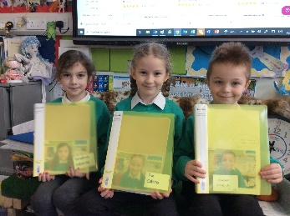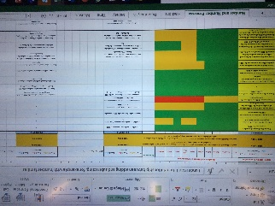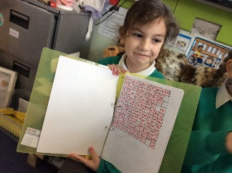

- The introduction of the Family Liaison Officer has increased families to come forward this session, whereby staff, families, partner agencies come together to support individual families. This has highlighted the need for greater services within the local rural community and the strategy to create a Community Wellbeing Strategy, to empower families in the services they needs whilst working with the school community to support the development of the Health and Wellbeing curriculum and the needs of our children.
- All teachers were involved in Wraps spelling, making good use of peer observations, moderation to share practice and consistency within learning and teaching. All targeted children made improvements in spelling.
- Pupils are continually consulted on improvements and weekly pupil council meetings take place; “If you make a suggestion at our pupil council meetings, then we usually discuss them and they usually happen.” P7 pupil.
Community
- Community, families and children were consulted on the revised Vision, values and aims. This resulted in the renewed sketch note and combining of the Teddy Bear Policy; Safe, Secure and Happy. This was relevant as we transitioned into our third session of impacted by COVID.
- We have continued to increase our modes of communication to ensure our Parent Council is kept up to date with information and particularly funding streams. Families are regularly updated on impact of funding streams and the priorities within the school community as well as the opportunity to discuss and vote on their preferred choices of how funding is allocated.
- Early Years Family Support Worker was implemented from Nov 21, as a service agreement with NHS Health Visiting Team to increase involvement and engagement. This has facilitated one to one art therapy sessions and a safe space to talk. Families receive regular wellbeing calls and home visits to further develop and discuss supports required to support parenting.
- All children are invited to join one of the 6 school community committees, taking ownership to lead an aspect of school development. Children act as leaders of learning twice annually to showcase their learning to families; this year children produce virtual videos and in the summer term, families attended class sessions.

Comment on progress made with Pupil Equity Funding, taking account of the five key areas below:
- attendance;
- attainment;
- exclusion;
- engagement;
- Participation.

Attendance FSM
Attainment – Teacher , Smartboard
Engagement stats - Myon, AR, Seesaw, Count on Us, FSW
P7 Residential Trip
Non – Talk for Writing, Barnardross, Targeted Psychotherapy
Didn’t take place

Quality Indicator | How are we doing? | How do we know? (Evidence) | School Self-Evaluation (1-6)
1.1  Self-Evaluation for Self-improvement | -Staff have undertaken SEAL training with CB and MM.  -Moderation activities, frequency increased  -Collaboration with other schools | - SAC teacher SEAL – dignosic to identify gaps, targeted learners, collegiate discussions, evidenced  -Further Collaboartion with other school  -Pupils access own learning files for LIT/NUM & choose how to reflect  -Fortnightly staff meetings/ moderation sessions  -HT observations & peer observations  - Continuous data discussions/ relfcetions | 5
1.3  Leadership of Change | -VVA – children involved, all stakeholders  -Teddy bear policy  -Staff leading committees  Children as Leaders of learning (workshops/ clubs)  -Learning logs LIT/NUM  -All staff assigned Curr. Dev area to learn change | -RRS Assemblies, ECO  -All children in a committee  -Re-introduction of Clubs Aug/Sept 22  -Evidence improved engagement from children | 5
2.3  Learning, teaching and assessment | -Weekly reflections linking to 4 capacities; all stakeholders involved in VVA revisiting Aug/Sept 21  -Wee HGIOS discussions (SEAL/WRAPS) | -SNSA scores showing increase in improvements  - Themed weeks; DYW, STEAM, HEALTH WEEK, Team events, Outdoor learning days/ Eco days  -Delivery of Forest schools and outdoor learning session twice weekly for every child  -Daily tracking tool devised  -Analysis from qualitative to quantitative | 4
3.1  Ensuring wellbeing, equality and inclusion | -COVID 19 recovery  Weekly SHANARRI wheel review, HWB pupil questionnaire  -Introduction of RSHP  -Safe spaces to talk and developed trusted relationships with FLO/ FSW  - Utilising outside agencies | -Agency involvement ELCC, supporting transitions to P1  -Children & Families supported by F.L.O  -Children aware of their own rights and how to keep safe  -Linking with Pupil Service, Community Service/Adult learning, active schools  -Seasons For Growth | 5
3.2  Raising attainment and achievement | -SEAL Teacher  -Wraps targeted intervention  -Nurturing approaches ELCC & Emotion Coaching ELCC  - FLO & F.S.W.EY  -Creation of further data analysis spreadsheet to support L&T  -Further tracking to be calculated for wider achievement | -Nurture groups ELCC and P1 from Aug 22 (Boxhall Profile)  -Wider achievement wall – WOW wall  - SNSA & Blackwell spelling  - P& A (XBRA) DATA  -School data tables  -Transition Focus – PT with HA  - Looking at all data across whole school as a whole staff | 4

